

Worksheet-2: C++ Basics

Submitted by – James Limbu

Submitted to - Aashish Acharya

Task 1: Basic student grading system prototype using classes and objects. [30 Marks]
Write a program that manages a simple student grade calculator with the following requirements. Create a student class that has:
1. Student name (string)
2. Three subject marks (integers)
3. A basic member function to calculate average
The program should:
1. Accept student details (name and marks) from user input
2. Calculate and display:
1. Total marks
2. Average marks
3. Grade (A for ≥90%, B for ≥80%, C for ≥70%, D for ≥60%, F for <60%)
3. Display a message if any mark is below 0 or above 100
#include <iostream>
using namespace std;
class student {
public:
string student_name;
string three_subject[3];
int three_subject_marks[3];

void student_details() {
cout << "Enter student name: ";
cin >> student_name;
cout << "Enter first subject: ";
cin >> three_subject[0];
cout << "Enter second subject: ";
cin >> three_subject[1];
cout << "Enter third subject: ";
cin >> three_subject[2];
}

void student_marks() {
cout << "Enter marks for first subject: ";
cin >> three_subject_marks[0];
cout << "Enter marks for second subject: ";
cin >> three_subject_marks[1];
cout << "Enter marks for third subject: ";
cin >> three_subject_marks[2];
}

void total_marks() {
int total = three_subject_marks[0] + three_subject_marks[1] + three_subject_marks[2];
cout << "Total marks: " << total << endl;
cout << "Average marks: " << total/3.0 << endl;
if(total>=90){
cout<<"you have grade A";
}
else if(total>= 80){
cout<<"you have grade B";
}
else if(total>= 70){
cout<<"you have grade C";
}
else if(total>= 60){
cout<<"you have grade D";
}
else{
cout<<"you have grade F";
}
}

};

int main() {
student final;
final.student_details();
final.student_marks();
final.total_marks();
return 0;
}
Outputs:
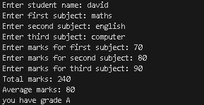
1. user input, its average marks and grade.

Task 2: Programming assignments: All questions are mandatory
1. Write a program with a class Circle having:
1. Private member: radius (float)
2. A constructor to initialize radius
3. A friend function compares Two Circles that takes two Circle objects and prints which circle has the larger area
#include <iostream>
using namespace std;

class Circle {
private:
float radius;
public:
const float pie = 3.14;
float circle_one;
float circle_two;

void first_circle() {
cout << "Enter the radius (in cm) for the first circle: ";
cin >> radius;
circle_one = pie * (radius * radius);
}

void second_circle() {
cout << "Enter the radius (in cm) for the second circle: ";
cin >> radius;
circle_two = pie * (radius * radius);
}

void output() {
if (circle_one > circle_two) {
cout << "The first circle has a larger area: " << circle_one<< endl;
}
else if (circle_two > circle_one) {
cout << "The second circle has a larger area: " << circle_two << endl;
}
else {
cout << "Both circles have the same area: " << circle_one << endl;
}
}
};

int main() {
Circle c1;
c1.first_circle();
c1.second_circle();
c1.output();
return 0;
}
Outputs:
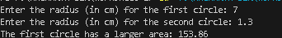
1. if the user inputs the more radius in second circle.
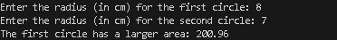
2. if the user inputs more radius in first circle.

2. Create a program with these overloaded functions named find Max:
1. One that finds maximum between two integers
2. One that finds maximum between two floating-point numbers
3. One that finds maximum among three integers
4. One that finds maximum between an integer and a float
#include<iostream>
using namespace std;

void findMax() {
int a, b;
cout << "PLEASE ENTER THE FIRST INTEGER: ";
cin >> a;
cout << "PLEASE ENTER THE SECOND INTEGER: ";
cin >> b;
if (a < b) {
cout << "THE SECOND INTEGER IS MAXIMUM (" << b << ")" << endl;
}
else if (a > b) {
cout << "THE FIRST INTEGER IS MAXIMUM (" << a << ")" << endl;
}
else {
cout << "BOTH INTEGERS ARE EQUAL (" << a << ")" << endl;
}
}

void findMax(float a, float b) {
cout << "ENTER THE FIRST FLOATING-POINT NUMBER: ";
cin >> a;
cout << "ENTER THE SECOND FLOATING-POINT NUMBER: ";
cin >> b;
if (a > b) {
cout << "THE FIRST FLOATING-POINT NUMBER IS LARGER (" << a << ")" << endl;
}
else if (b > a) {
cout << "THE SECOND FLOATING-POINT NUMBER IS LARGER (" << b << ")" << endl;
}
else {
cout << "BOTH FLOATING-POINT NUMBERS ARE EQUAL (" << a << ")" << endl;
}
}

void findMax(int a, int b, int c) {
cout << "PLEASE ENTER THE FIRST INTEGER: ";
cin >> a;
cout << "PLEASE ENTER THE SECOND INTEGER: ";
cin >> b;
cout << "PLEASE ENTER THE THIRD INTEGER: ";
cin >> c;

if (a >= b && a >= c) {
cout << "THE FIRST INTEGER IS MAXIMUM (" << a << ")" << endl;
}
else if (b >= a && b >= c) {
cout << "THE SECOND INTEGER IS MAXIMUM (" << b << ")" << endl;
}
else {
cout << "THE THIRD INTEGER IS MAXIMUM (" << c << ")" << endl;
}
}

void findMax(int a, float b) {
cout << "PLEASE ENTER AN INTEGER: ";
cin >> a;
cout << "PLEASE ENTER A FLOATING-POINT NUMBER: ";
cin >> b;

if (a > b) {
cout << "THE INTEGER IS LARGER (" << a << ")" << endl;
}
else if (b > a) {
cout << "THE FLOATING-POINT NUMBER IS LARGER (" << b << ")" << endl;
}
else {
cout << "BOTH NUMBERS ARE EQUAL (" << a << ")" << endl;
}
}

int main() {
cout<<"||||||||||||||||||||||||||||||||||||||||||||"<<endl;
cout<<" CHOOSE FROM GIVEN NUMBERS "<<endl;
cout<<"1.MAXIMUM BETWEEN 2 INTEGERS"<<endl;
cout<<"2.MAXIMUM BETWEEN 2 FLOATS.P"<<endl;
cout<<"3.MAMXIMUM BETWEEN 3 INTEGERS"<<endl;
cout<<"4.MAXIMUM BETWEEN FLOAT AND INTEGERS"<<endl;
cout<<"||||||||||||||||||||||||||||||||||||||||||||"<<endl;
int a;
cin>>a;
if(a==1){
findMax(); // Two integers (no args)
}
else if(a==2){
float x, y;
findMax(x, y); // Two floats
}
else if(a==3){
int p, q, r;
findMax(p, q, r); // Three integers
}
else if(a==4){
int m;
float n;
findMax(m, n); // One int and one float
}
else{
cout<<"please choose number form above!!! ";
};

return 0;
}
Outputs:
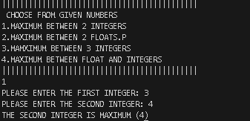
1. If the user inputs option 1.
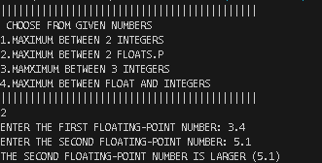
2. If the user inputs option 2.
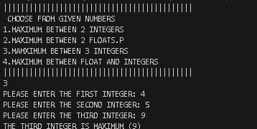
3. if the user inputs option 3.
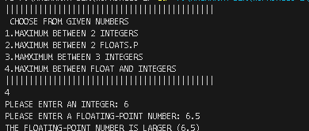
4. If the user inputs option 4.
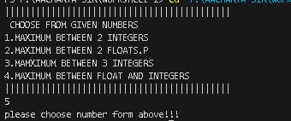
5. if the user inputs outside the given option.

Task 3: Basics of File Handling
Write a program that reads the titles of 10 books (use an array of 150 characters) and writes them in a binary file selected by the user. The program should read a title and display a message to indicate if it is contained in the file or not.
#include<iostream>
#include<fstream>
using namespace std;
void forBooks(){
char books[10][150];
ofstream file("bks.bin");
if (!file) {
cout << "Error opening file!" << endl;
}
cin.ignore();
for (int i = 0; i < 10; i++) {
cout << "Enter " << i + 1 << " book name: ";
cin.getline(books[i], 150);
file << i + 1 << ". " << books[i] << endl;
}

file.close();
cout << "Books have been saved to the file." << endl;

}
void forBooksdetails(){
ifstream file("bks.bin");
if(file.is_open()){
string line;
while(getline(file,line)){
cout<<line<<endl;}
}
}
void forBooksChecking(){
ifstream file("bks.bin");
char searchbook;
cout<<"ENTER THE NAME OF THE BOOK YOU WANT TO SEARCH"<<endl;
cin>>searchbook;
char ch;
bool found=false;
while(file.get(ch)){
if (ch==searchbook){
found = true;
break;
}

}
if (found){
cout<<"THE BOOKS IS IN LIBRARY!!"<<endl;
}
else
cout<<"SORRY THE BOOKS IS NOT AVAILEABLE IN THE LIBARARY!"<<endl;
}
int main() {
int option;
cout<<"CHOOSE FROM BELOW"<<endl;
cout<<"1.CHANGE BOOKS THAT ARE IN LIBRARY"<<endl;
cout<<"2.CHECK BOOKS THAT ARE AVAILEABLE IN LIBRARY"<<endl;
cout<<"3.CHECK IF TITLE IS AVAILEABLE IN LIBRARY"<<endl;
cin>>option;
if(option==1){
forBooks();}
else if(option==2){
forBooksdetails();}
else if (option==3){
forBooksChecking();
}
return 0;
}
Outputs:
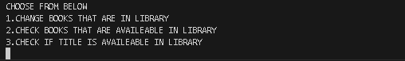
1. First output when user runs the code
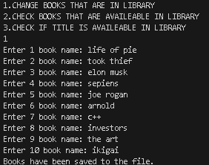
2. if user chooses option no 1.
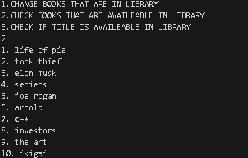
3. if the user chooses option no 2.
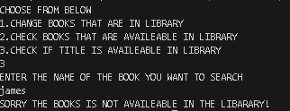
4. if the user put the book title that is not available.
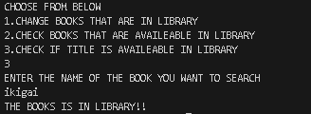
5. if the user puts the book title that is available in the library.

Create a program that:
- Reads student records (roll, name, marks) from a text file
- Throws an exception if marks are not between 0 and 100
- Allows adding new records with proper validation
- Saves modified records back to file

#include <iostream>
#include <fstream>
#include <string>
using namespace std;
class student {
int roll;
string name;
float marks;
public:
student() : roll(0), name(""), marks(0.0f) {}
void getinput() {
cout << "Enter roll: ";
cin >> roll;
cout << "Enter name: ";
cin >> name;

while(true) {
cout << "Enter marks (0-100): ";
cin >> marks;
if(marks >= 0 && marks <= 100) break;
cout << "Invalid marks! Must be between 0-100.\n";
}
}
void display() {
cout << "Roll: " << roll << endl;
cout << "Name: " << name << endl;
cout << "Marks: " << marks << endl;
}
void saveToFile() {
ofstream file("students.txt", ios::app);
if(file) {
file << roll << " " << name << " " << marks << endl;
cout << "Student saved to file!\n";
} else {
cout << "Error saving to file!\n";
}
}
void readFromFile() {
ifstream file("students.txt");
if(file) {
cout << "\nStudent Records:\n";
while(file >> roll >> name >> marks) {
display();
cout << "--------\n";
}
} else {
cout << "No records found!\n";
}
}
};

int main() {
student s;
int choice;
do {
cout << "\n1. Add new student\n";
cout << "2. View all students\n";
cout << "3. Exit\n";
cout << "Enter choice: ";
cin >> choice;

switch(choice) {
case 1:
s.getinput();
s.saveToFile();
break;
case 2:
s.readFromFile();
break;
case 3:
cout << "Exiting...\n";
break;
default:
cout << "Invalid choice!\n";
}
} while(choice != 3);

return 0;
}
Outputs:
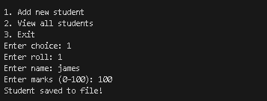
1. If the user inputs option no 1
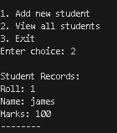
2. if the user inputs option no 2
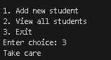
3. if the user chooses option no 3.
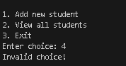
4. if the user chooses outside the given option

